**Lesson Notes**

1. What is the main purpose of an Operating System?

The main purpose of an operating system is to make the system more simple and efficient while providing a consistent user experience while having multiple applications running at the same time.

1. What is the difference between Operating System Software and User Application Software?

Applications focus on what is contained and displayed within a window

Operating System controls opening / closing / resizing windows and responding to mouse and keyboard actions

Operating System provides standard ways to print, save and open files, access the internet, etc.

Applications just ask for what they need (e.g. Memory, Disk Space)

Operating System checks for availability and access permission

Operating System coordinates resource allocation between applications

1. What is the difference between Operating System Software and Computer Hardware?

Same applications can run on different computer hardware

Operating System must be configured according to hardware components present in the computer

1. What are the main parts of an Operating System?

Graphical User Interface (GUI)

Windows Display, mouse, keyboard, sound, etc.

System Calls

Device Drivers

I/O Manager

Memory Manager

Process Manager

Security Monitor

1. What are some popular operating systems?

Windows OS

Mac OS

Linux / Unix

Android

iOS

**Reference Diagram**

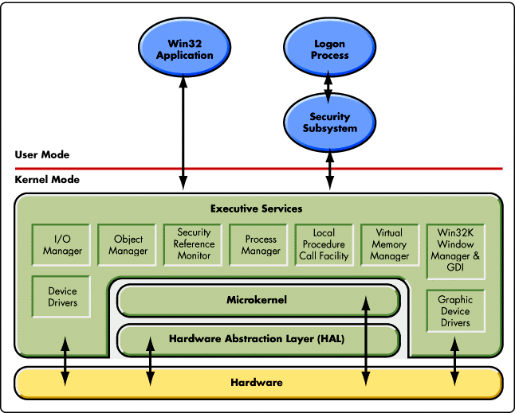

**Student Questions**

1. What is a device driver?
   1. Provide a brief summary

A device driver is a computer program that operates or controls a particular type of device that is attached to a computer.

* 1. List some devices that require a device driver.

CD-ROM readers, network or sound cards, computer mice or hard disks.

* 1. Provide a label on the reference diagram for the location of a device driver for your graphics card.
  2. Provide a label on the reference diagram for the location of a device driver for a locally attached printer.

1. What is a DLL?
   1. Provide a brief summary

DLL is a dynamic link library file format used for holding multiple codes and procedures for Windows programs.

* 1. Explain how DLLs are related to user application programs

It is connected to user applications because DLL library codes hold multiple codes for the applications

* 1. Provide a label on the reference diagram for the location of a DLL

1. What is a windows manager?
   1. Provide a brief summary

A window manager is system software that controls the placement and appearance of windows.

* 1. Explain how a windows manager is related to user application programs

It controls the windows that a user is currently using, e.g. Microsoft word and PowerPoint

* 1. Provide a label on the reference diagram for the location of a windows manager

1. What is the windows task manager?
   1. Provide a brief summary

Windows task manager allows you to monitor the applications, processes and services running on your pc.

* 1. List and explain four (4) types of system information provided by the task manager

Processes, Applications, Services and Performance.

* 1. Provide a label on the reference diagram for the operating system components related to each type of information.